Wednesday, June 15th, 2022

Hi guys,

Good to keep in touch with you again !

Today I’m with you via Cloud, as I am at the airport now ready for take off. I apologize for not having our zoom class today. Thank you for the photos and captions you sent me yesterday and today. Well done !

Now let’s review our **Simple Present Tense** by doing these small exercises here and send them back to **my Private Whatsapp : 082218880160** by **Thursday, 16 June 2022 at 23.59 wib.** Thank you. ☺

Thank you.

**1. Make the present simple, positive, negative or question:**

1. I ____ (to be) in a café now.

Answer : I am in a cafe now

1. ______ (she / play) tennis every week?

Answer : does she play tennis every week?

1. They ____ (go) to the cinema every Wednesday.

Answer : they goes to the cinema every Wednesday

1. _____ (she / to be) a singer?

Answer : is she a singer?

1. You _______ (find) the weather here cold.

Answer : you finds the weather here cold

1. ______ (they / to be) on the bus?

Answer : are they on the bus?

1. Lucy ________ (ride) her bicycle to work.

Answer : Lucy rides her bicycle to work

1. Why _____ (he / to be) in France?

Answer : Why is he in France?

1. They ______ ( not / like ) durian.

Answer : They are not like durian

1. Sinta ______ ( to be ) a great singer.

Answer : Sinta is a great singer

2. Next, please make **captions for these pictures in Simple Present Tense**, like you did in your first assignment, but this time you have to make **3 captions** for each picture :

1. **Positive / Affirmative.**
2. **Negative.**
3. **Interrogative / question.**

**Example :**

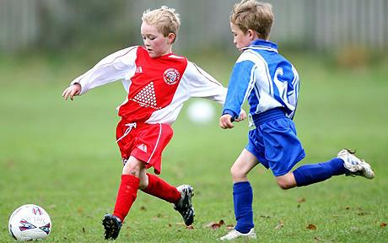

1. The kids **play** soccer.
2. The kids **don’t play** soccer.
3. **Do** the kids **play** soccer ?



1. she makes breakfast
2. she doesn’t make breakfast
3. Does she make breakfast?



1. he swims in the pool
2. he doesn’t swim in the pool
3. Does he swim in the pool?

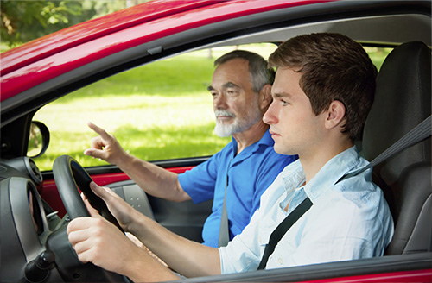

1. He drives a car with his father
2. he doesn’t drive a car
3. Does he drive a car?



1. they are work together
2. they are not work together
3. do they work together?



1. she sings a song
2. she doesn’t sing a song
3. does she sing a song?

That’s it guys ! Please try to do the exercises and send your answers to me, we’ll discuss them on Friday via Zoom.

If you have any questions, please text me via WA and I’ll reply to you ASAP !

Thank you, enjoy your day and see you soon !

Cheers

Your Cikgu Rilwan ☺